TRC3500 - Sensors and Artificial Perception
Project 3: Breath Rate Estimation

Changelog
THIS IS A LIVING DOCUMENT, please do not print. Clarifications and corrections will continue to be made after it is released.
28-04-25: Released for Semester 1 2025
22-03-26: Released for Semester 1 2026, Malaysia campus
04-05-26: Slight modification to enhance the report requirements

Submission Guidelines
- In-lab demonstration will be conducted in Week 12 lab session. The details of the demonstration procedure are listed in the subsection below.
- One group member should upload all deliverables to GitHub or a cloud storage service, then include the URL in the report.
- Report (maximum eight pages, including appendix) should cover the following:
  - Circuit schematics and clear photographs of the sensor and breadboard
  - Report that clearly shows (1) use of two sensors (2) any interface circuits (3) STM32, (4) live readings that (5) capture the breathing responses from two sensors, (6) DSP technique applied (7) Data fusion technique applied (8) indicate an estimated breath rate over some time period
  - Clear description of the prototype design (signal conditioning and algorithm), design decisions, supported by informative figures/diagrams.
  - Appropriate DSP technique applied (noise reduction, compression, or calibration).
  - Successful combination of two complementary sensor outputs into a unified breathing rate estimate, using a logical and error-free technique.
  - Critical evaluation of system performance, including:
    - Mean-squared error (MSE) calculation using ground truth, including histograms of errors, for all activities.
    - Just-noticeable-difference for both sensor conditions and the relative performance, including psychometric curve(s).
    - Discussion of what worked and what didn’t.
    - Reflection on the potential benefit of a third sensor.
  - GitHub or cloud storage service URL
  - Declaration of generative AI use
- Notes on collaboration:
  - We will use ITP metrics to re-weight grades according to participation.
  - Please keep good, contemporaneous, notes on your contributions, contribute directly to a shared Google document for transparent version history, and commit your contributions to GitHub. We will request access to these as data to resolve any conflicts among team members.

Learning objectives
Your breadboard and report should provide evidence that you can perform and understand the following tasks:
- Design and construct the physical system required to apply sensors to the needs of a particular task
- Adapt basic signal conditioning circuits to the particular calibration needs of your sensing elements
- Use an STM32 microcontroller to multiplex analog inputs
- Use DSP techniques to process sensor data either in real time or post-hoc
- Use data fusion techniques to combine estimates from multiple sensors
- Demonstrate changes in system performance that depend on design decisions
- Produce a report and breadboard that meet professional standards

Materials
Student provides
- Eleclab toolkit
Provided to each group
- 10cm of conductive rubber
- Thermistor (TMP61)
- 2.5m of double sided hook and loop strap

Safety Notes
1. Be mindful of that this system will be close to your body, so do not leave any exposed wires or sharp edges in your design
2. Remember not to use the sensors if you or your clothes are wet, as you could cause shorting that could hurt you or damage the hardware

Briefing
Project title: Enhancing Breath-Rate Monitoring via Multi-Sensor Data Fusion
Client Division: VitalTech Solutions, HealthTech R&D Division
Date Issued: 28-04-25
Confidentiality Level: Internal Development
VitalTech Solutions is a leader in wearable biosensing technology for personal health monitoring, sports recovery, and early clinical diagnostics. Their product line includes wristbands, adhesive patches, and smart fabrics capable of continuously monitoring cardiovascular, respiratory, and activity signals in real-world conditions.
Recent user testing revealed that single-sensor breath-rate monitors are prone to failure during moderate movement, noisy environments, or when sensor positioning is less than ideal. This creates risk in contexts such as sleep apnea detection, athletic training feedback, or ambulatory patient monitoring.
You have been seconded to the VitalTech R&D Integration Team, tasked with prototyping a more robust breath-rate sensing module by combining data from multiple sensors. This module may be integrated into our next-generation wearable system, BreatheWell™.
Your task: Design and validate a sensing system that uses data from multiple sensor types to estimate breath rate more reliably than any single sensor alone.
Technical Requirements
- Design a circuit that integrates two complementary sensors (i.e., sensors that detect breathing using different physical principles) capable of detecting breathing-related changes. You may use the provided sensors: thermistor (temperature changes from breath), sphygmomanometer (air pressure changes, not intended for final wearable use), and conductive rubber cord (strain detection). Note: the sphygmomanometer is best suited for initial data collection and algorithm development, not for final wearable integration.
- Collect data for each of the conditions (compulsory for a, and b). Other conditions are optional.
  - Resting
  - Heavy exercise (e.g. Running or any heavy exercise that increase the breath rate significantly)
  - Talking or reading aloud (optional)
  - Light movement (optional, e.g., walking or fidgeting)
  - Stretch goal (optional): active movement like jogging on the spot.
- Apply at least one digital signal processing technique to the sensor data, either online (embedded system) or offline (Python). Your DSP method should achieve one of the following goals:
  - Noise reduction
  - Data compression
  - Sensor calibration
- Use a data fusion technique to combine the outputs of both sensors into a unified breath-rate estimate. You may fuse the raw time series before estimation, Or independently estimate breath rate from each sensor, and then combine the two estimates.
- Performance evaluation - demonstrate your system's performance for a single-sensor and two-sensor design. For ground truth, we recommend using a metronome set to a comfortable rate and instructing the person testing the prototype to breathe in time with the metronome (if you do not have a physical metronome, there are many free apps). Quantify this in terms of:
  - mean-squared error
  - just-noticeable-difference

Deliverables
- Technical Report (up to 8 pages). This should include:
  - A brief description of your approach and any notable design decisions alongside their rationale
  - A walk-through of your digital signal processing pipeline, with figures showing the effect of your signal processing on raw data.
  - A description of how you performed your data fusion, and an example for a single trial.
  - A description of your method, data collected and results for your performance evaluation. This should include the histograms of your errors you use to measure mean-square-error. If you also measure just-noticeable-difference for one or both of these conditions, show the psychometric curve(s) you find. Include MSE results for all activity types. Do not measure JND for more than one activity type, it is a very time consuming process!
- Photo of breadboard and circuit schematics. These may be in the report as an appendix or attached separately.

Additional Notes
Due to some minor issues with the thermistor and pressure sensor datasheets, please refer to the following when designing your sensing circuits. Note that all sensors have a very small output change, so amplification will be required. Note that these instructions are provided as helpful guidance. If you think a different approach will be more interesting or effective, you can feel free to pursue it

TMP61
This thermistor functions as though it has a diode inside, so the orientation of the thermistor is important as it affects what type of conditioning circuit is required. Please connect as per figure if you would like the effective resistance to match 10K at 25℃. It is recommended that you place these close to your face.
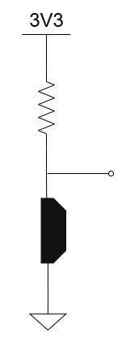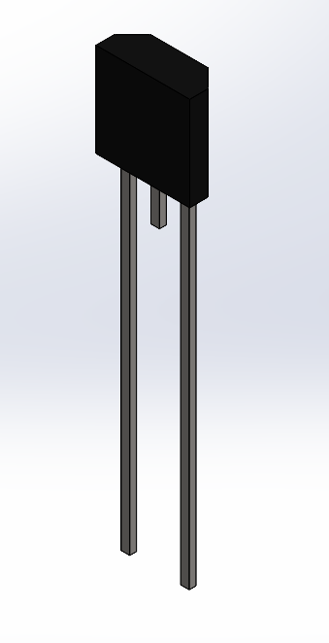
1
2
10K
Signal
1+
2-
Figure 1: TMP61 connections a) 3D view with pin numbering, b) connection circuit diagram

Conductive Rubber
For building the harness for your conductive rubber it is recommended that you wrap it around your belly, create loops by twisting the strap on itself then tie your alligator clips wires around these loops to hold them in place. Then clip the rubber to the alligator clips and attach wires to the plastic connectors on the other end of the alligator clips. This should allow for easy adjustment of size and tightness.
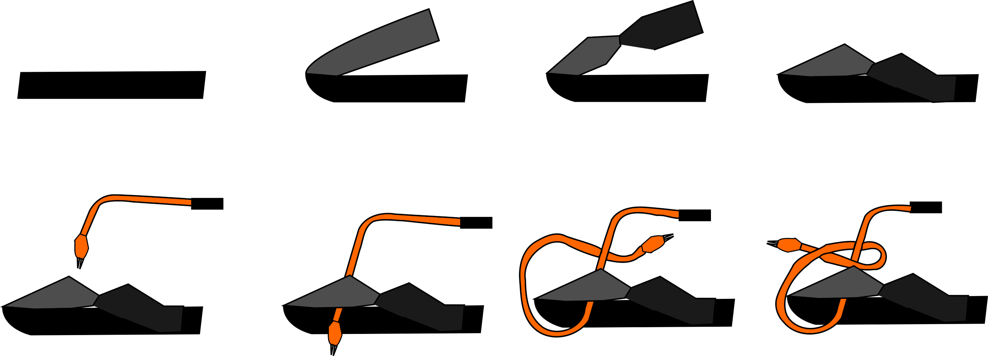
Bend
Twist
Hook
Through
Loop
Tie off
Wire
Figure 1: Instructions for rubber sensor harness

In-Lab Demonstration (6 marks)

Make sure all the group members are present.
- At least two complementary sensors are integrated and operating correctly in real time. Sensor data clearly responds to breathing events: 1 mark
- DSP technique applied (noise reduction, compression, or calibration): 1 mark
- Resting breathing rate: using a metronome as ground truth. Demo will use the metronome app, and we will go with 5 cycles.
  - 100% correct breath rate match (±0 cycles): 2 marks
  - Partial correct breath rate, within ±1 breathing cycles: 1 mark
  - Wrong breath rate, more than +-2 breathing cycles: 0 mark
- Light/heavy exercise breathing rate: manual breath-cycle counting (count for 30 seconds after exercise) as ground truth; start counting as soon as the student sets up the sensing devices on the body.
  - 100% correct breath rate match (±0 cycles): 2 mark
  - Partial correct breath rate, within ±2 breathing cycles: 1 mark
  - Wrong breath rate, more than +-3 breathing cycles: 0 mark

Rubric
Total 20 marks | Pass | Credit | Distinction | High Distinction
Sensor and Circuit  (6 marks) | In-lab demonstration  - The system meets some but not all of the design requirements.  - There are no or inappropriate conditioning circuits that may contain significant mistakes. | In-lab demonstration  - The system meets all of the design requirements, but may contain some mistakes. The conditioning circuit may not scale the sensor output appropriately.  - Not all activity types may be viable because of poor wearability/stability of the physical components.. | In-lab demonstration  - The system meets all design requirements with only a few minor mistakes.  - The conditioning circuit scales the sensor output to maximise the ADC range.  - The prototypes are sufficiently stable to operate on all activity types. | In-lab demonstration (100%)  - The system meets all design requirements with no apparent mistakes in reasoning or implementation.  - The analog components produce high-quality output that is refined, not salvaged, with DSP.  - The prototypes are stable enough to operate even during active use.
Digital Signal Processing  (4 marks) | Report  - Digital signals from the sensors are processed to meet at least one appropriate goal, but the approach may be weak or contain significant errors.  - There may be no or little sensible rationale given for the approach. | Report  - Digital signals from the sensors are processed to meet at least one appropriate goal.  - The approach is suitable for the goal and implemented correctly or with minor errors. - There is some coherent rationale for the approach communicated in the report. | Report  - Digital signals from the sensors are processed to meet at least one appropriate goal.  - The approach is ideal and likely to produce a meaningful performance improvement.  - There are few errors if any.  - Rationale is clearly stated and sensible. | Report  (40%) Digital signals from the sensors are processed to meet one or more appropriate goals.  (30%) The approach is ideal, and there are few if any errors.  (30%) The rationale for the approach is clearly stated and consistent with overarching design priorities.
Data Fusion  (3 marks) | Report  - Two data sources are combined, but may be done with some error or an inappropriate technique. | Report  - Two data sources are combined using an appropriate technique, but there may be minor errors. | Report  Two data sources are combined using an appropriate technique without errors. | Report  (100%) Two data sources are combined, without errors, using a sufficiently strong technique to improve system performance.
Performance Assessment  (4 marks) | Report  - Performance is assessed with mean-square-error, and one- and two- sensor conditions are compared.  - Data collected for this may be weak, but appropriate. | Report  - Appropriate, sufficient data are used to calculate mean-square-error for one- and two-sensor conditions with no or very minor errors. | Report  - Appropriate, sufficient data are used to calculate mean-square-error for both conditions, and compellingly demonstrate and describe the relative performance of approaches. | Report  (100%) Appropriate, sufficient data are used to calculate mean-square-error and just-noticeable-difference for both conditions, and the relative performance of the approaches is compared and thoughtfully discussed.
Professional Standards  (3 marks) | Report  - The report text is incoherent in sections, contains mistakes, or does not consistently address the aims of the report.  - Figures may be missing one or more pieces of information.  - Breadboard has not been tidied, circuit diagrams are not completely labelled.  - AI Use Declaration may be absent or inappropriate. | Report  - The report is readable and appropriate figures have been selected to communicate results.  - Breadboard is interpretable, and circuit diagrams are labelled.  - AI Use Declaration present, may lack detail. | Report  - The report is clear and relevant.  - Figures are appropriate, tidy and contain all essential information.  - Breadboards are clear and clean, and circuit diagrams meet all professional standards.  - AI Use Declaration present and clear. | Report  (20%) The report is clear, relevant, and insightful.  (30%) Figures are compelling and well-integrated with the text.  (20%) Breadboards are easy to understand, and follow a consistent convention.  (20%) Circuit diagrams meet all professional standards.  (10%) AI Declaration from complete and submitted.

Full marks are listed in High Distiction column only. The details for demonstration marks are listed in In-lab demonstration subsection.

